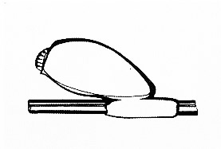
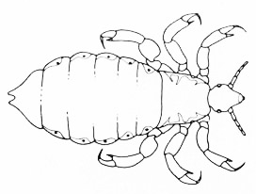
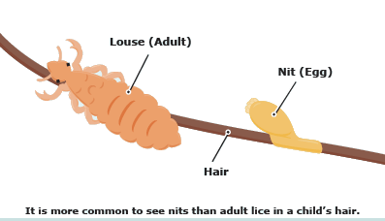
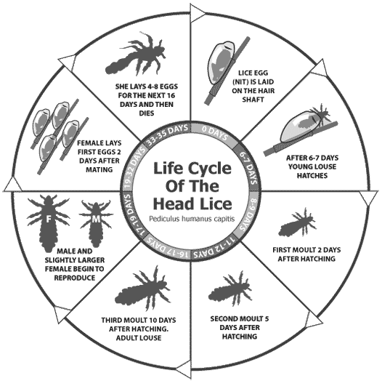

Who is it?

 It's a louse
 They eat human blood: they can eat 5 times in a day

draw

 Head lice are transmitted
by head to head contact
or by clothes to clothes contact

draw
FILASTROCCA DEI PIDOCCHI
Se ti gratti sulla testa
ma il prurito non si arresta
non ti devi preoccupare
ma soltanto controllare.
Sai cos’è la pediculosi?
Sono insetti dispettosi
ben nascosti fra i capelli
fanno a gara di saltelli
pungono come le zanzare
ma tu ti devi organizzare:
shampoo speciale e pettinino
e li sistemi… per benino!
Basta fare il trattamento
e finisce il loro divertimento:
fine di salti, punture e banchetti!
Testa pulita, capelli perfetti.
Autrice: Simona Maiozzi

 The eggs of lice are called nits. They are oval white cylinders. The eggs of head lice are usually glued to hairs of the head near the scalp.

What's a louse?

 A louse is an insect that lives on people's head

 Head lice are small,

 Their colour varies from whitish-brown to reddish-brown.

 Head lice haven't wings or jumping legs : they cannot fly or jump from head to head.

have you got head lice?
 Wash the hair in the normal way with special shampoo.
 Comb the hair with a lice comb
 then check, comb, and remove nits and lice from hair every two or three days.
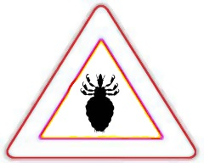
w
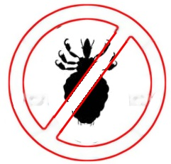
 Head lice only survive on humans. If isolated from the head they die very quickly (usually within 24 hours). They are parasites!
Scuola primaria
"Ada Negri"
Busto Arsizio
Anno scol. 2012/13
Classi 3A/B
www.schoolmate.it

